Office Manager/Teacher resource: Administrating your school’s Bikeability training

Introduction
This document is intended to provide support for those members of the teaching/administrative staff who have the responsibility within their school for organising the Bikeability training.
The appointed Bikeability training provider will, of course, provide day-to-day support and all the necessary documentation.

Contents
- What is Bikeability
- Why do it
- Organising training
- Important notes
- On the day
- Post course
- Appendix - Social media engagement

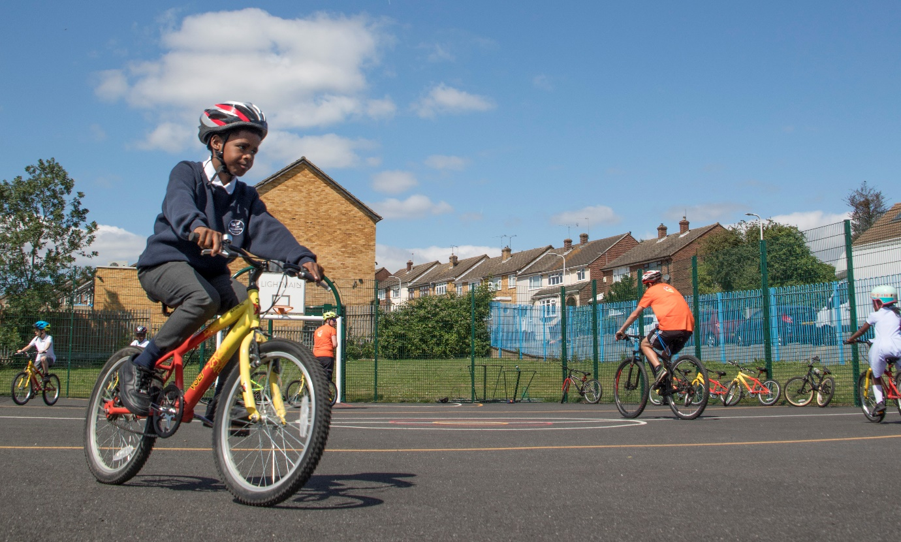
- What is Bikeability?
Bikeability is the national cycle training programme for children in schools. Bikeability is funded by the Department for Transport, and is delivered by qualified, professional, DBS checked National Standard Instructors.
Bikeability is delivered in three stages:
- Level 1 - Bikeability aims to develop cycle handling in an off-road environment and prepare riders for cycling on the road. Riders must be able to cycle (i.e. pedal and glide) to participate in Bikeability Level 1. Stand-alone Level 1 training typically happens during year 3 and 4.
- Level 2 - Bikeability will develop riders’ skills and confidence for cycling on single-lane roads and simple junctions with mostly moderate motor traffic flows, preparing riders to deal with short journeys such as cycling to school or the local shops. Level 2 training is typically delivered combined with Level 1 during school year 5 or 6.
- Level 3 - Bikeability equips riders with the skill and confidence to ride in more challenging roads and traffic situations, such as busier streets, queuing traffic, complex junctions and roundabouts. It also includes planning routes for safe cycling. Riders must have completed Level 2 prior to Level 3. This training typically takes place during school years 7 – 9.

Local Authority grant recipients receive funding to deliver Bikeability training in their county or metropolitan borough. Training itself is delivered by a Bikeability Provider contracted to the grant recipient, and in some cases, may be the grant recipient themselves. Training may be provided to the end user either partially or fully subsidised.
The Bikeability Provider is responsible for organising the training and will deliver the training using Bikeability Instructors who are qualified to deliver training, either employed or engaged on a freelance basis to the training provider.

- Why offer Bikeability to your pupils?
Bikeability training will equip children with the capability and awareness to cycle confidently on the roads.
Cycling has many benefits: it is an essential life skill for children teaching them, inter alia, co-ordination, spatial awareness and confidence in their own abilities. It offers them the opportunity for independence and a sustainable travel option, plus it provides a healthy activity with physical and mental benefits. By encouraging more cycling amongst children (and their families) post Bikeability training, it can contribute to less traffic on local roads with the associated improvements in air quality and road safety.

- How do I go about organising training?

- Identify your local Bikeability provider
If you plan to deliver Bikeability for the first time and have not been contacted directly by the Bikeability provider, you need to contact your local authority. You can do this by searching for ‘Bikeability’ on your council’s website and using the contact details found there.
You may also use the search function here at www.bikeability.org.uk/find-a-course and enter your borough name to find relevant contact details.
Your local Grant Recipient will be able to inform you who your local provider is, relevant contact information, which Bikeability modules are available, what costs may be involved and when training can be carried out.

- Arrange a date
In liaison with the training provider, settle on a date(s) for the training to take place. Check whether the course will be delivered over consecutive days or over a few weeks (i.e. every Monday for four weeks). Training can be delivered at any point during the year, not just the summer term.

- Request course documents
The training provider will provide you with information on course duration and course structure. This will be specific to each training provider. For a course where instructors work on a 1:6 ratio with the trainee riders, riders will receive eight hours training minimum, two hours for Level 1, and two hours for Level 2. However, smaller ratios will mean the course duration can be shorter.
The training provider will also send you a consent form for parents, which will need distributing well in advance of the course.
d. Promote the course to parents
Parents will appreciate as much information as you can send their way. Your training provider will supply you with a template consent form. This can be further supplemented with directing parents to www.bikeability.org.uk (either from your newsletter, email updates or website). We would particularly recommend this link: https://bikeability.org.uk/bikeability-training/get-ready/ or https://bikeability.org.uk/cycle-more/family-cycling/bikeability-parents-handbook/. Your Bikeability provider may also have a good online resource to direct parents to.
- Engage your class
Talk to your children about the course. You can access videos via YouTube by searching for ‘Bikeability’. After publicising the course, ask for a show of hands to establish the numbers interested. Please communicate this to the training provider, in order to firm up course schedule.
There are a set of resources available to teachers here: including a presentation, posters, activity sheets and lesson plans.

- Finalise numbers
Consent forms should be returned at least one month prior to the course beginning, and a register provided to the Bikeability provider. Consent forms (with SEND information and photo consent) should be kept securely for the instructors to check on the first day of training.
Remain in touch with the training provider in case of changes to course attendees. For changes in the weather (e.g. extreme hot, cold or wind), it is advisable to reschedule training.

- Important notes
- For a Level 2 course, children must be able to cycle unaided for about a minute without any assistance (including stabilisers). This is not a course to teach them to ride. If a child cannot cycle, they will not be able to continue with the course.
- It is essential that any medical or SEND information is communicated to the provider prior to the course.
- Children will need to arrive for training with a fully working bike. If a bike is deemed un-roadworthy, the child will not be able to continue with the course, and a full description of the faults will be provided for the parent.

- On the day
Make the instructors feel welcome, direct them to key areas within the school such as the classroom, the playground, access offsite, the staff toilets and staff room.
The instructors will provide a Risk Assessment and give a very clear description of where training will be delivered. After each session, there should be a debrief with the instructors outlining what was achieved and discussing any issues.
It also helps if the children are organised and ready for their training promptly.

- Post course
Each child will be provided with a certificate, badge and booklet as part of their ‘award materials’. This will either be completed on the day or sent after course completion. You will also receive a course report from the training provider.

- Encouraging on-going cycling
Finally, please note that Bikeability does not have to be the end of a child’s cycling journey, it should very much be a springboard. Parents and children can be signposted to www.bikeability.org.uk and to your local training providers website for more training opportunities, helpful information and activities to get involved with.
Also talk to your local authority or training provider about how you can turn your school into a national example of good practice, encouraging more teachers to cycle to school through cycle to work schemes, the provision of good cycle storage, and improvements to cycle infrastructure in local area etc.

Appendix 1: Social Media engagement
Bikeability Guide: Promoting your Schools course through social media
Here are a few suggested posts to engage with your parents about Bikeability on social media (Facebook and Twitter @BikeabilityUK)
The Bikeability Instagram account is @bikeabilitytrust. But we recognise that this platform is used much less frequently by schools.
The red text below will need editing, i.e. course dates or social media handles of the training provider.

- Announce
Great news - we will be running Bikeability on [DATE] Year 6 parents [or 5 depending] Look out for letters coming home, also visit www.bikeability.org.uk for more information about the course.
@BikeabilityUK @BIKEABILITY PROVIDER HANDLE

- Add a reminder to chase consent forms (2-3 weeks before)
Year 6 [or 5 depending] Bikeability is fast approaching on [DATE]. Get your consent forms in soon and don’t forget to sign up to the Bikeability club here: www.bikeability.org.uk/bikeability-club/ for more resources and chances to win.
@BikeabilityUK @BIKEABILITY PROVIDER HANDLE

- Make sure everything is in order prior (1 week before)
Year 6 [or 5 depending] Make sure you are prepared for Bikeability on [DATE]. Get your bike, helmet and clothing sorted - www.bikeability.org.uk/bikeability-training/get-ready/
@BikeabilityUK @BIKEABILITY PROVIDER HANDLE

- During
Whilst the course is happening, you have an ideal opportunity to take photos and upload to your chosen social media platform, provided you have the relevant permissions. Upload images with your own text and tag @BikeabilityUK @BIKEABILITY PROVIDER HANDLE

