The Wild Tribe Achievement Award Scheme

This award has been developed, in response to a request, from a teacher who delivers Wild Tribe sessions at their school. It can be seen as a mini Duke of Edinburgh Award Scheme for primary aged children. The award will be overseen by the school but elements of it can be done at home and in the community.

Aim
The aim of the award is to develop the child as a rounded individual; a child that has fun, grows in confidence, learns new life skills and gains an appreciation of nature. These children will be able to cope with successes and failures and will have a positive outlook on life. It is divided into 3 levels, Bronze, Silver and Gold and within each level there are four strands:

- Health and Wellbeing
- Volunteering and Leading
- Life Skills
- Respecting and Enjoying the Environment

To complete a level, the child will need to take part and have signed off a number of elements in each strand. Many of the elements involve being outdoors. Once the four strands have been completed, the child MUST take part in the Adventure Challenge to complete that level of the award.

Health and Wellbeing
Health and Wellbeing can be described as being healthy, safe, comfortable and happy. Such essential attributes lead to a child being both mentally and physically strong. There are many ways in which we can help a child to develop these qualities so that they become resilient and independent and can lead positive happy lives. The activities in this section will develop the young person’s self esteem, their understanding of how to be healthy by being active, eating healthy foods and enjoying the outdoors particularly with others. For example:

Bronze: Go on a nature walk.
Silver: Design and make a healthy snack.
Gold: Plant, grow and care for an edible plant that you can use when cooking on an open fire.

Volunteering and Leading
A child is never too young to volunteer for, or to lead an activity and this will develop their sense of personal power. Through this section they will learn to recognise the needs of others, how to lead activities for their peers and other groups and understand how volunteering brings families, schools and communities together. For example:
Bronze: Organise a game for some friends to play
Silver: Lead a warmup for a PE lesson
Gold: Do a weekly good deed/errand for someone in need (home, school or community) on a regular basis for a month or more, for example, bake cakes, go to the local shops, take out their recycling/rubbish.

Life Skills
There are many skills essential for life especially if we want to be healthy and happy and this section encourages children to learn new skills such as First Aid, safe biking, using tools safely and for a purpose, lighting fires, cooking in the outdoors and working as a team. For example:

Bronze: First Aid: Learn your own address, home emergency phone number and how to make an emergency call.
Silver: Use a tool safely to make something out of wood.
Gold: Take part in Bikeability Level 2.

Respecting and Enjoying the Natural Environment
The outdoors is such a fabulous place to be whether it is the beach on a windswept day, the moors on a moonlit night, the local woods or park, the school site or your back yard / garden. Research has shown how being and enjoying the outdoors can have a major impact on our health and wellbeing and this section promotes some fun but also challenging activities for children to tackle. The activities use the skills from the previous section along with their understanding of how to be resilient. It also teaches them to respect the environment – to look after it for future generations. For example:

Bronze: Identify 4 trees and take leaf or bark rubbings of them.
Silver: With supervision, use at least 2 tools, for example, hammer or drill, to make something from wood.
Gold: Make a rope ladder and use it.

Adventure Challenge
Each level has a final challenge named after an ‘adventurous’, well known person. For example:

Bronze: The Greta Thunberg Adventure Challenge reflects the determination of a young person doing something small that grows into something great. For example, the impact of growing a tree.
Silver: The Steve Backshall Adventure Challenge encompasses the skills of an adventurer and the awareness of our fragile planet. For example, completing a physical challenge with the ability to observe the wild spaces on your journey.
Gold: The David Attenborough Adventure Challenge is about gathering and using the skills from all levels of the award to provide the ultimate challenge. By taking the time to reflect about our planet, the leaders of tomorrow can begin taking steps to ‘work with nature’.

How it works
Each level, Bronze, Silver and Gold has four sections. Depending on the level, children have to complete a certain number of tasks / activities as follows:

 | Bronze | Silver | Gold
Health and Wellbeing | 3 | 5 | 7
Leading & Volunteering | 3 | 5 | 7
Skills | 3 | 5 | 7
Respecting & Enjoying the Environment | 3 | 5 | 7

There is a choice of activities in each section that the children choose from. Some are designed to be completed at school, some at home and some in the community. It might be that the school decides to choose some of them and work as a class to complete but this does not have to be so. It could be an award that children opt in or out of. Once the activities have been completed from each section, the children MUST take part in the relevant Adventure Challenge to complete the award.

When to complete each level
Again, there is no set way when children can start or finish this award. It is a progressive award in that the tasks get more challenging from Bronze through to Gold. Some children maybe more ready to start with the Bronze challenges in Year 1 than others. However, the schools can organise as they see best taking individual needs of children into consideration. For organisational purposes if a school would like this to be a whole school award, it could be seen that the awards are attempted as follows:

Bronze KS1
Silver Y3/4
Gold Y5/6

Booklets
The booklet gives an introduction to the award and then a chart for each of the 3 levels. Each element of an award that is completed needs to be signed and dated. The booklet remains with the child throughout their school life. There is a small space for the children to provide some evidence of their Adventure Challenge that they completed, or they may wish to produce their own scrapbook.

Awards
A certificate will be awarded for the completion of each level – Bronze, Silver and Gold. This will be on the USB stick that the school receives when purchasing the award.
Additional awards are available direct from the suppliers: Sew on embroidered badges- £2.50 approx plus VAT and Medals- £1.50 approx
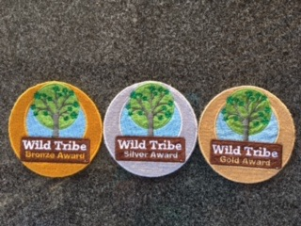

Evidence
Once a level of the award has been completed by a group of children, we will require a short piece of evidence. Please see the link below.

Cost- £150 A one off payment.
For a USB stick that has
- The booklet for your children
- This information sheet for teachers
- The Bronze, Silver and Gold Certificates
Also available to purchase separately are sew on cloth badges and / or medals. These are available directly from the suppliers.

Links
To register your interest, so that you get sent the USB stick and your school is invoiced, please scan the QR code with your phone’s camera.
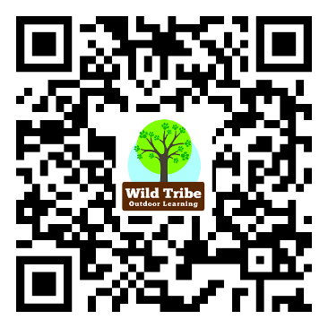

To evidence completion of the award, please click here.

To purchase embroidered badges please contact Glynn Valley Chefs Wear Unit 11 Miller Business Park, Station Road, Liskeard, PL14 4DA 01579 345677 sales@glynnvalley.com

To purchase the medals, please contact sales@runningimp.co.uk

For any further questions, please contact info@arena-schools.co.uk or visit our website www.arena-schools.co.uk

