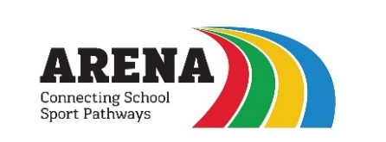

Sports Development Coach

Contract Type – Fixed Term until 31st August 2022 (It is hoped this will be extended until 31st August 2023 for a suitable candidate subject to funding)

Pay scale UQT 1 – 6 (£18,169 – £28,735 Full time) pro rata

Work pattern – 20 – 25 hours per week - 0.6 – 0.8

Start Date – As soon as possible

We are looking for enthusiastic and dedicated sports coaches to join are highly successful team. Due to an increase in our work programme we have a vacancy for a sports development coach to cover the North Cornwall area of the sports partnership the role will be for approximately 20 – 25 hours hours per week but this could increase. You will need to have a minimum of a level 2 NGB Sports coaching qualification and have had experience in working with primary age children.

Arena is a successful sports partnership providing services to primary schools across North and East Cornwall. We offer continued professional development to all our staff. This is an exciting opportunity for candidates who are looking to develop their career in PE and Outdoor. For more information about our work visit our website at www.arena-schools.co.uk.

To apply please contact mroberts@callingtoncc.net for relevant forms and further information.

Deadline for applications – Midday on Monday 2nd May 2022

Interviews – Thursday 5th May 2022

We are committed to safeguarding children and the successful applicant will be required to undertake an enhanced Disclosure and Barring Service (DBS) check, and will be assessed against the Childcare Disqualification Regulations.

